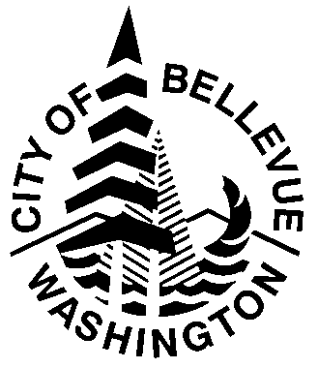
Hold Harmless, Indemnification & Insurance

The Event Sponsor is organizing an event to take place in Bellevue, WA. The Event Sponsor agrees to the following terms and conditions:

1. Hold Harmless and Indemnification:

- The Event Sponsor shall protect, defend, indemnify, and save harmless the City, its
officers, employees, and agents from any and all costs, claims, judgments, and/or awards of damages, arising out of, or in any way resulting from, the negligent acts or omissions of the Event Sponsor, its officers, employees, and/or agents in the performing this agreement. The Event Sponsor agrees that its obligations under this subparagraph extend to any claim, demand, and/or cause of action brought by, or on behalf of, any of its employees or agents. For this purpose, the Event Sponsor, by mutual negotiation, hereby waives, as respects the City only, any immunity that would otherwise be available against such claims under the Industrial Insurance provisions of Title 51 RCW. In the event the City incurs any judgment, award, and/or cost arising therefrom including attorneys’ fees to enforce the provisions of this article, all such fees, expenses, and costs shall be recoverable from the Event Sponsor.

- The City shall protect, defend, indemnify, and save harmless the Event Sponsor, its officers, employees, and agents from any and all costs, claims, judgments, and/or awards of damages, arising out of, or in any way resulting from, the negligent acts or omissions of the City, its officers, employees, and/or agents in performing this agreement. The City agrees that its obligations under this subparagraph extend to any claim, demand, and/or cause of action brought by, or on behalf of, any of its employees or agents. For this purpose, the City, by mutual negotiation, hereby waives, as respects the Event Sponsor only, any immunity that would otherwise be available against such claims under the Industrial Insurance provisions of Title 51 RCW. In the event the Event Sponsor incurs any judgment, award, and/or cost arising therefrom including attorneys’ fees to enforce the provisions of this article, all such fees, expenses, and costs shall be recoverable from the City.

2. Insurance
The Event Sponsor shall maintain insurance requirements as outlined in Special Events City Code 14.50.140.

IN WITNESS WHEREFORE, the parties have executed this Agreement as of , 20

Event Sponsor: City of Bellevue:

By:________________________________ By: ______________________________
(Signature) (Signature)

Name: Name: Shelley Brittingham
(Type Name)
Title: Title: Assistant Director
(Type Title)
Sponsoring Organization: __ ________________________
(Type Organization Name)
Event Name: Event Date:
(Type Name) (Type Date(s))

