Linen Order Form
South Bellevue Community Center

Linens in a variety of sizes and colors are available to rent at a very affordable price through South Bellevue Community Center. To reserve linens for your event, please complete the following information and email to SBCC@bellevuewa.gov, fax to (425) 452-7912, or deliver to SBCC to complete your request.
Linen requests must be received three (3) weeks prior to your event date.
Customer Name:
Rental Date:
Rental Start Time:
Room Reserved:

Table Cloths - $4.00 each:
52 x 52 Great for use over a card-size table. Makes an ordinary table beautiful.
Ivory#: White#: Black#:
114 x 53 Creates a 21”drop on a 6 foot-long table.
Ivory#: White#: Black#:
85 x 85 Great for a 5’ round table that creates a 13.5” drop. Consider two for added length!
Ivory#: White#: Black#:

Napkins - $0.50 each:
Check which color you want below and indicate quantity above.
White (# ) *Bistro (# ) *White w/Navy Striping
Black (# ) Ivory (# )
Red (# ) Burgundy (# )
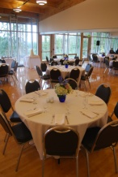
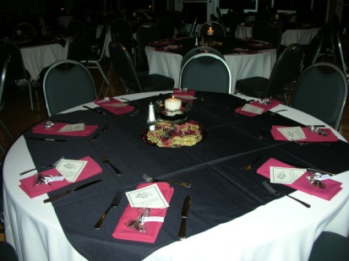
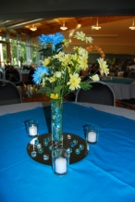
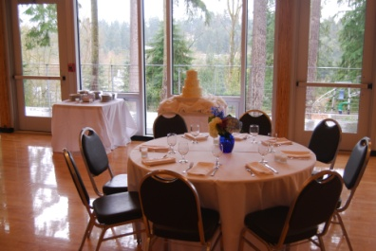

Tablecloths and napkins not returned at the end of the rental will result in an additional charge at the same rate per linen.

