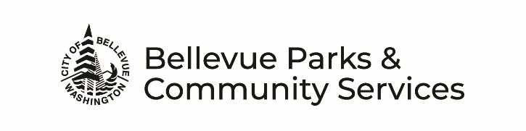

FACILITY USE REQUEST FORM
parks.bellevuewa.gov/rentals/

ORGANIZATION: TODAY’S DATE:
PRIMARY CONTACT NAME: NON-PROFIT ID#:
EMAIL: CELL PHONE:
ADDRESS: WORK PHONE:
CITY: HOME PHONE:
STATE: ZIP:
ALTERNATE CONTACT NAME: CELL PHONE:
EMAIL:
NAME OF FACILITY: ROOM(S):
DATE(S) REQUESTED (Attach separate sheet if needed):

TIME REQUESTED (Must include setup & cleanup time): TO TOTAL HOURS:

TYPE OF ACTIVITY/USE:
EVENT TIME (Guest arrival and departure): TO

IS THE EVENT? Private (have a guest list, know who is attending or limited to a set number of people) OR
Public (public is invited through word-of-mouth, flyers, or media advertising)
ANTICIPATED MAXIMUM ATTENDANCE? Total: By Age Groups: ADULTS CHILDREN

AGREEMENTS
The undersigned hereby makes application to City of Bellevue for use of the Parks & Community Services facility described above and certifies that the information given in the application materials is correct. The undersigned further states that he/she has the authority to make this application for the applicant and agrees that the applicant will observe the rules, regulations, policies and procedures of the City of Bellevue and Parks & Community Services Department. The applicant assumes responsibility for the conduct of their guests and/or contractors associated with or attending the event. The applicant agrees to exercise the utmost care in the use of the premises and property and to hold the City of Bellevue harmless from all liability resulting from the use of said facilities. The applicant further agrees to reimburse the City of Bellevue for any damage arising from the applicant’s use of said facilities. The applicant signing this agreement will be considered the responsible party in case of damage, theft, or disturbances during the rental period.
I have read, understood, and agree to comply with all procedures in the City of Bellevue’s Facility Rental Guidelines and the Supplemental Form documents for the facility I am requesting to use. I further certify that I am 21 years of age or older.

SIGNATURE (REQUIRED): Primary Contact: Date:
In lieu of my signature, I certify that I have an account with Bellevue Parks & Community Services and that by providing my User ID# I am acknowledging I am the holder of the account and agree to all the terms listed above.

In addition to this form, complete and submit Facility Supplemental Form, Credit Card Authorization Form, and Indoor Facility Special Use Form (if applicable).
Mailing Address: City of Bellevue
Parks & Community Services
Attn: Rentals at
PO Box 90012
Bellevue, WA 98009-9012

