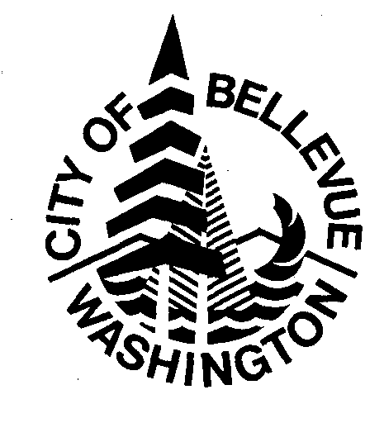
1309 114th Ave SE, Suite 200 • Post Office Box 90012 • Bellevue, WA • 98009-9012

Probation Services (425) 452-6956 FAX: (425) 452-7883
EHD (425) 452-4461 FAX: (425) 452-4467

COMMUNITY SERVICE AGREEMENT FORM

I understand community service is a privilege and an obligation and that I am responsible for abiding by all rules and requirements of the Bellevue District Court, Bellevue Probation and the work site. Failure to do so may result in termination from the community service program and/or return to court. Work may be performed for any non-profit organization within the Bellevue City limits, unless otherwise approved by a supervisor, and will be credited at the rate of $20.00 per every full hour of work.

I will provide proof of all hours completed to Bellevue Probation on the non-profit organizations letterhead and signed by an authorized person who is familiar with the work I have completed. The letter will contain the following information:
- Verifiable contact information for the authorizing person.
- The dates and times of when I worked.
- A description of the work I performed.
- My court case number.

Signature: ______________________________________ Date: ____________

Witness: _______________________________________

Total community service hours to be completed: ______________
Name of community service work site: ________________________________________
Work site supervisor: ____________________________________ Ph # _______________________

