NBCC Supplemental Form
parks.bellevuewa.gov/rentals/

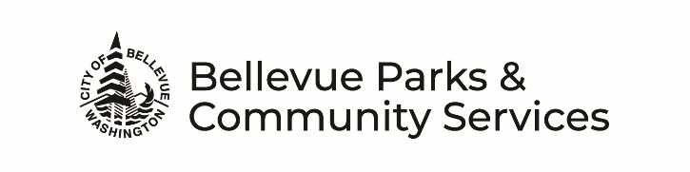
EVENT DETAILS
How will the space be used? (mark all that apply)
Meeting Class/Lesson Wedding Party Other (describe):

Will food be served? No Yes If yes, who is providing? Bringing it ourselves or
Food Vendor/Caterer Dropped-Off or Food Vendor/Caterer to stay at the park facility during event *
Will there be music? No Yes If yes, who is providing? Bringing own system or Facility system or
Hiring a DJ * or Live (which instruments?)
Will there be other Entertainment or Games? Examples: game truck, face painter, bubble soccer, magician, animal show, photo booth, inflatable ride etc… No Yes
If yes, what is planned?
Who is providing it? Bringing it ourselves or Hiring a company *
Will there be other Additional Equipment brought in? Examples: laptop, AV equip, chairs, tables, decorations, staging, etc… No Yes If yes, what is planned?
Who is providing it? Bringing it ourselves or Hiring a company *
* Special Uses: If hiring a company to provide a service for the event, a permit is required and must be approved in advance. An Indoor Facility Special Use Form is required, deadline to meet requirements is 21 days prior to event date.

Will alcohol be served? No Yes Will alcohol be sold? No Yes
If yes, a Washington State Liquor & Cannabis Control Board Banquet Permit or Special Occasion License and alcohol server with a Class 12 Permit are required. See Facility Rental Guidelines for all requirements that must be met a minimum of 7 days prior to event date for approval.

Will admissions be collected? No Yes If yes, estimated amount?
Will items be sold? No Yes If yes, what is planned?
EQUIPMENT (included with rental)
Renters are responsible for the care, condition, and cleaning of any equipment being used. The room has an inventoried set of tables/chairs available for use. It is the responsibility of the applicant to set-up, move tables and chairs for their purpose and to return room to original condition.
Room Equipment needed: (mark all that apply and fill in quantities where applicable):
Stacking Chairs (250 avail.) 6 ft Rectangular Tables (20 avail.) 5 ft Round Tables (25 avail.) Tabletop Podium Portable Screen Audio System Microphone Coat Rack
Portable Stage Portable Accordion Room Dividers Piano (additional charge)
Kitchen Equipment needed:
Refrigerator/Freezer Microwave Dish Sanitizer Range/Oven Convection Oven Warming Trays

CONTACT INFORMATION
North Bellevue Community Center: After Hours Emergencies:
Facility Location: 4063 148th Ave NE, Bellevue, WA 98007 Bellevue Parks Resource Management
Mailing Address: PO Box 90012, Bellevue, WA 98009 Phone: 425-452-6855
Phone: 425-452-7681
Fax: 425-882-1968
Email: NBCC@bellevuewa.gov

