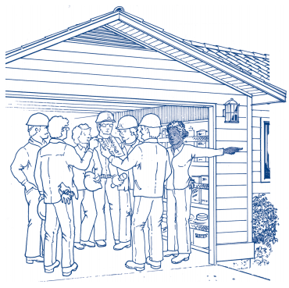
ENTER DIGITAL SIGNATURE HERE:
X _______________________________________________________________________________
LEADER CONTACT INFORMATION (all fields required)
MAP YOUR NEIGHBORHOOD (MYN)
RESOURCE REQUEST FORM
Bellevue Office of Emergency Management
OEMPublicEd@bellevuewa.gov

NAME:
E-MAIL ADDRESS:
MAILING ADDRESS:
TELEPHONE:
ATTENDED LEADER TRAINING: | DATE: | LOCATION:
GENERAL INFORMATION (all fields required)
NEIGHBORHOOD TO BE
BE MAPPED (INCLUDING
HOUSE NUMBERS):
MATERIALS NEEDED BY:
QUANTITY NEEDED BY:
DATE SCHEDULED FOR YOUR
MAPPING EVENT:
TIME ALOTTTED:
The MYN Program was developed by the Washington State Military Department, Emergency Management Division, and is offered through Local Emergency Management offices. By signing this document, you agree
that all information gathered as a result of the mapping shall be used exclusively for the MYN Program.

