MSEEC Supplemental Form
parks.bellevuewa.gov/rentals/
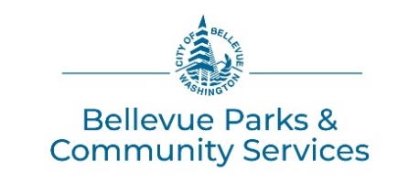

EVENT DETAILS
How will the space be used? (mark all that apply)
Meeting Class/Lesson Wedding Party Other (describe):
Will food be served? No Yes If yes, who is providing? Bringing it ourselves or
Food Vendor/Caterer Dropped-Off or Food Vendor/Caterer to stay at the park facility during event *
Will there be music? No Yes If yes, who is providing? Bringing own system or MSEEC system or
Hiring a DJ * or Live (which instruments?)
Will there be other Entertainment or Games? Examples: face painter, magician, animal show, photo booth, etc…
No Yes If yes, what is planned?
Who is providing it? Bringing it ourselves or Hiring a company *
Will there be other Additional Equipment brought in? Examples: AV equip, chairs, tables, decorations, staging, etc… No Yes If yes, what is planned?
Who is providing it? Bringing it ourselves or Hiring a company *
* Special Uses: A permit is required in advance if hiring a company to provide any services or equipment for the reservation. An Indoor Facility Special Use Form must be submitted no less than 30 days prior to the reservation date to be considered for approval.
Will alcohol be served? No Yes Will alcohol be sold? No Yes
If yes, a Washington State Liquor & Cannabis Board Banquet Permit or Special Occasion License and an alcohol server with a Class 12 Permit are required. See Facility Rental Guidelines for all requirements that must be met a minimum of 14 days prior to the reservation date for approval. Alcohol service may not be approved during hours of scheduled youth programs in the complex.
Will admissions be collected? No Yes If yes, estimated amount:
Will items be sold? No Yes If yes, what is being sold?
Are you aware that there is limited parking at this facility? Yes
Note: There are only 10 parking spaces in the parking lot for MSEEC rentals, plus 2 ADA spaces. You will be provided with a campus map. Carpools and shuttles are encouraged. Public on-street parking is available. If your reservation starts after 4pm there may be additional parking available, but not guaranteed.
EQUIPMENT (included with rental)
Renters are responsible for the care, condition, and cleaning of any equipment being used. The room has an inventoried set of tables/chairs available for use. Table coverings are required. It is the responsibility of the applicant to set-up, and move tables and chairs for their purpose and to return the room to its original condition.
Room Equipment needed: (mark all that apply)
Stacking Chairs (50 avail.) 6 ft Rectangular Tables (13 avail.) White Board/Easel (1 avail.)
LCD projector Pull-Down Screen PA/Wireless Mic Coat Racks Podium
Kitchen Equipment needed: Refrigerator Microwave 12-Cup Coffee Maker Hot Water Kettle
CONTACT INFORMATION
Parks Scheduling Office: After-Hours Emergencies:
Office Location: City Hall, 450 – 110th Avenue NE, Bellevue, WA 98004 Bellevue Parks Resource Management
Mailing Address: PO Box 90012, Bellevue, WA 98009-9012 Phone: 425-452-6855
Phone: 425-452-6914
Fax: 425-452-7221
Email: MSEECRental@bellevuewa.gov

