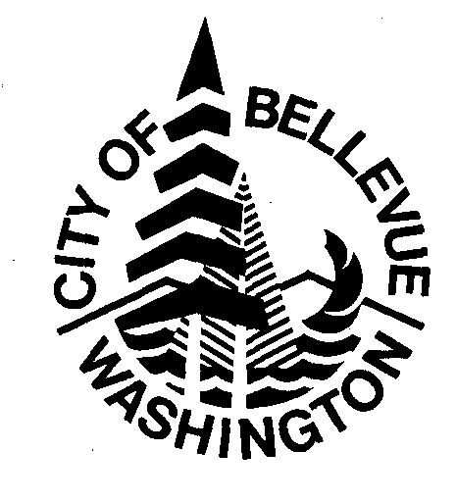City of Bellevue
Credit Card Authorization Form
Cardholder Name:
Organization Name (if applicable):
Billing Address:
City: State: WA Zip:
Mailing Address (if different):
City: State: WA Zip:
Cardholder Phone Number:
VISA or MasterCard Account Number: Exp. Date:
Amt Approved: $ (Not to exceed $ without written authorization.)
Rental Facilities for which this account number can be on file (check all that apply):
All Listed Facilities Athletic Fields Botanical Garden
Bellevue Youth Theatre Crossroads Comm. Center Highland Comm. Center
Kelsey Creek Park Lewis Creek Visitor Center MSEEC Community Room
Northwest Arts Center Outdoor Park Sites South Bellevue Comm. Center
Tyee Community Gym Winters House Other:

Is this authorization for a Single Rental or On-Going Use?
If Single Rental only this form will be kept on file in a secure location and all but the last 4-digits of the card number will be redacted after the final charge is processed.

If On-Going Use do you authorize the City of Bellevue to keep this form on file in a secured location to process rental payments on a regular schedule? Yes No
If Yes, you will be contacted to discuss the options (including frequency, amount, and opting out).

Does anyone else in your organization or family have authority to request that payments be made to this charge account? Yes No
If Yes, please provide their contact information and the maximum amount authorized for transactions requested by them without your written approval.
Name Phone Number Amount Approved
$
$
I understand that it is my responsibility to update this information as this authorization status or credit card expiration date changes occur. This authorization is effective on the date accepted and approved by the City of Bellevue and will remain in effect until rescinded by me or the City of Bellevue.

Printed Name Date

Cardholder Signature Daytime Phone Number
City of Bellevue Use Only:
Accepted:
Signature Date Client Barcode

