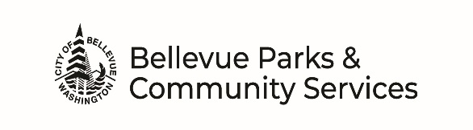
NORTHWEST ARTS CENTER
Facility Use – Supplemental Form

Applicant: Date of Event:

SPACE & USE
1. Indicate the studio(s) you want to reserve (rental of Studio C is required when renting for events with food or beverages):
☐ Studio B ☐ Studio C/Kitchenette ☐ Studio D
2. Indicate how you will use the space (mark all that apply):
☐ Meeting ☐ Class/Lesson ☐ Rehearsal ☐ Party ☐ Other (specify):

3. Will you be serving food? ☐ No ☐ Yes
If yes, who is providing? ☐ Group member ☐ Caterer Drop-off only
☐ Caterer serving on-site (permits are required; see Rental Guidelines)
If yes, do you need it kept heated? ☐ No ☐ Yes

4. Will you be serving alcohol? ☐ No ☐ Yes (permits are required; see Rental Guidelines)
5. Will there be music? ☐ No ☐ Yes
If yes, who is providing? ☐ NWAC Sound System ☐ DJ ☐ Live - List instruments:

6. Will you be collecting admissions? ☐ No ☐ Yes Estimated Amount:
7. Will you be selling concessions? ☐ No ☐ Yes Vendor Name:

EQUIPMENT
8. Describe any decorations, equipment or delivery for your event:
9. On-site NWAC equipment to be used (mark all that apply):
☐ Vinyl/metal stacking chairs ☐ 6 ft rectangular tables (20 available)
# chairs requested # tables requested
☐ Projector screen (must bring own projector) ☐ Table-top podium
☐ Cordless microphone (fees apply) ☐ Corded microphone w/ stand (fees apply)

10. If renting Studio C, kitchen equipment needed (mark all that apply):
☐ Microwave ☐ Range/Oven ☐ Refrigerator/Freezer ☐ Commercial Dishwasher
RULES & REGULATIONS SPECIFIC TO THIS FACILITY (initial each)
Hours: Rentals must end no later than 10 p.m. and premise must be vacated no later than 11 p.m.
Sound: Music must cease by 10:00 p.m.
Furnishings: Each room has an inventoried set of tables and chairs. It is the responsibility of the renter to set
up and move furnishing for the rental and return furnishings & equipment to their original position upon departure.
Trash: Empty trash cans and recycling bins that are at least half full into dumpsters located in parking lot.
Facility Rental Information: I have read and understand the “Facility Rental Guidelines” document.
CONTACT INFORMATION
NWAC Office: 9819 NE 24th Street, Bellevue, WA 98004 425-452-4106 NWAC@bellevuewa.gov

