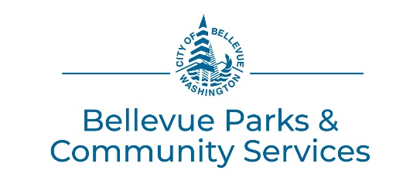
NWAC Rental Date Request Form
Maximum length of rental per Facility Use Request Form:
- Bellevue Residents: 12 months from request date
- Non-residents: 11 months from request date

Renter Name: Click or tap here to enter text.
Organization: Click or tap here to enter text.
Day(s) of the Week Requested: Click or tap here to enter text.
Non-Profit?: Choose an item.
Type of Request: Choose an item.
Enter the year in the dropdown by each month, type in the dates requested in the first column, then times under the studio.
JANUARY Choose an item. | STUDIO B (classroom) | STUDIO C (kitchen) | STUDIO D (dance studio)
FEBRUARY Choose an item.
MARCH Choose an item.
APRIL Choose an item.
MAY Choose an item.

JUNE Choose an item. | STUDIO B (classroom) | STUDIO C (kitchen) | STUDIO D (dance studio)
JULY Choose an item.
AUGUST Choose an item.
SEPTEMBER Choose an item.
OCTOBER Choose an item.
NOVEMBER Choose an item.
DECEMBER Choose an item.
Rental Notes: Click or tap here to enter text.

